**BankerAdvisor Feedback and change Request List**

**6 December 2019**

1. Based on our discussions with Andrii, Oleh, they would like the Google Tag manager integrated into BankerAdvisor.
2. Hotjar. Andrii, Oleh and I discuss adding Hotjar to the BankerAdvisor site. The tracking code for Hotjar for BankerAdvisor is:

<!-- Hotjar Tracking Code for www.bankeradvisor.com -->

<script>

(function(h,o,t,j,a,r){

h.hj=h.hj||function(){(h.hj.q=h.hj.q||[]).push(arguments)};

h._hjSettings={hjid:1602163,hjsv:6};

a=o.getElementsByTagName('head')[0];

r=o.createElement('script');r.async=1;

r.src=t+h._hjSettings.hjid+j+h._hjSettings.hjsv;

a.appendChild(r);

})(window,document,'https://static.hotjar.com/c/hotjar-','.js?sv=');

</script>

1. Appearance when no image is present. Since we had a complaint to remove a logo stating that BankerAdvisor was infringing on the bank’s intellectual property, it is reasonable to assume that in the future, we may have additional complaints to remove a firm’s logo. I would like to see if we can modify the logo display area (here) so that it is blank when no logo appears rather than how it currently is displayed if this is possible. This way, whether if we have to remove a logo or if a logo has not been added yet, the website will not appear that it is incomplete.

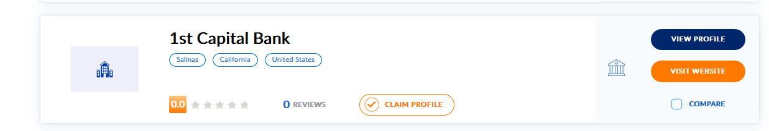

1. Search functionality and question. In the results tool bar, we have a search function. When I type in a search term “Boston” the results do not appear to be identifying the firms that are located in Boston. The example below shows a Seattle firm first and there many Boston firms in the database under investment banking. I want to inquire whether the search functionality is reviewing the location in the search process as this is an important feature. I would like the search function to be able to search on city, state/province as well as country and region to produce results that filter based on this data if possible.

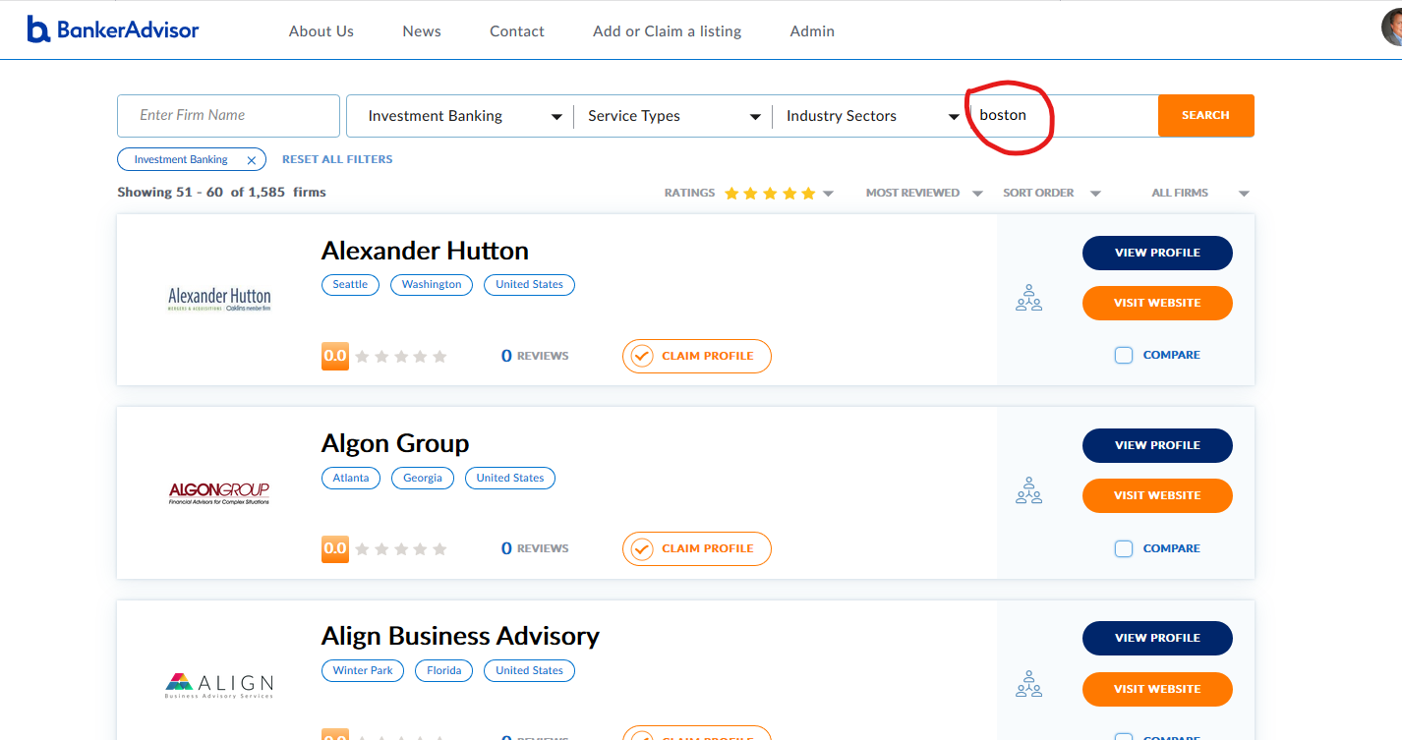

1. Search functionality – Search for BB&T bank. During some of my testing, I search on the bank BB&T. The results worked correctly when I typed in BBT

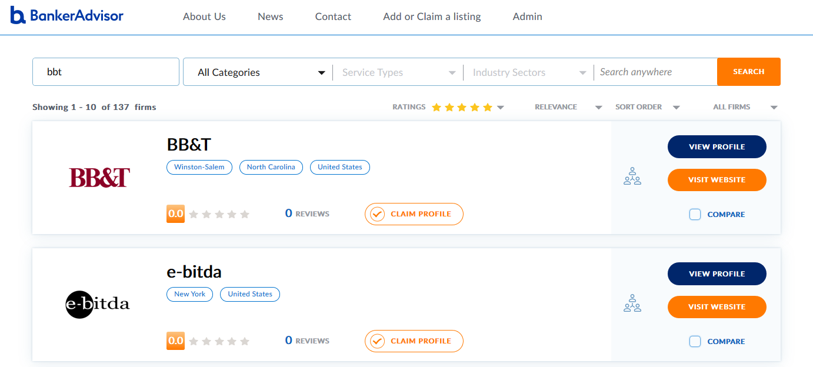

However, this is the result that you receive when you search on BB&T. there may be a minor error in the search functionality and I wanted to see if this was an isolated item or if we can make a change so that we get the correct results.

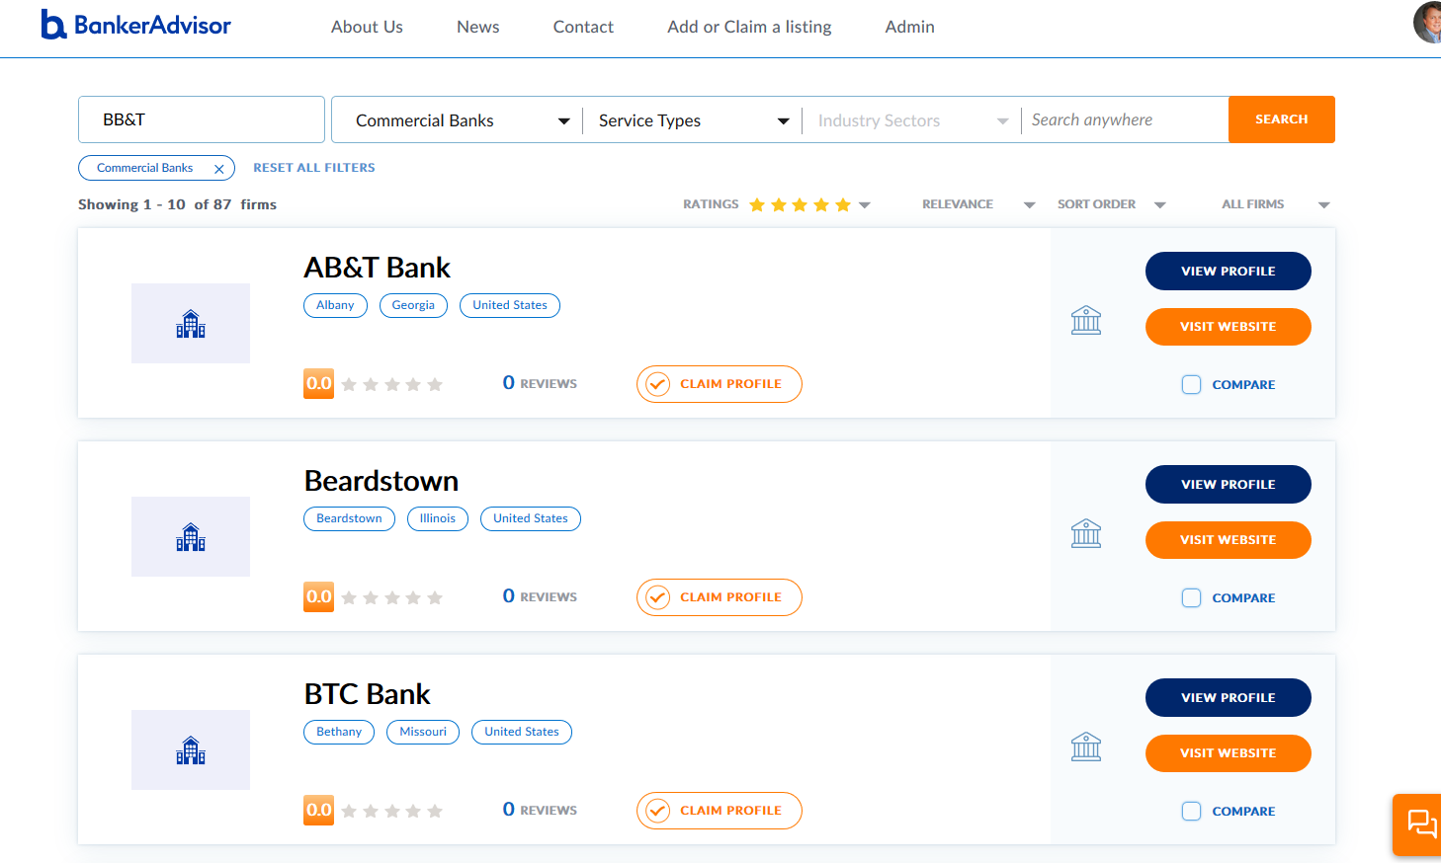

1. Search function – searching on the phrase “Missouri”. As noted, above when I search on the term “Missouri”, the results do not include the list of banks with the term “Missouri” in their name and the results do not include the Banks located in Missouri. I have included a screen shot from the admin panel where the search on Missouri appears to work well. I wanted to see if we can get this same result when using the search on the live site in the tool bar search.

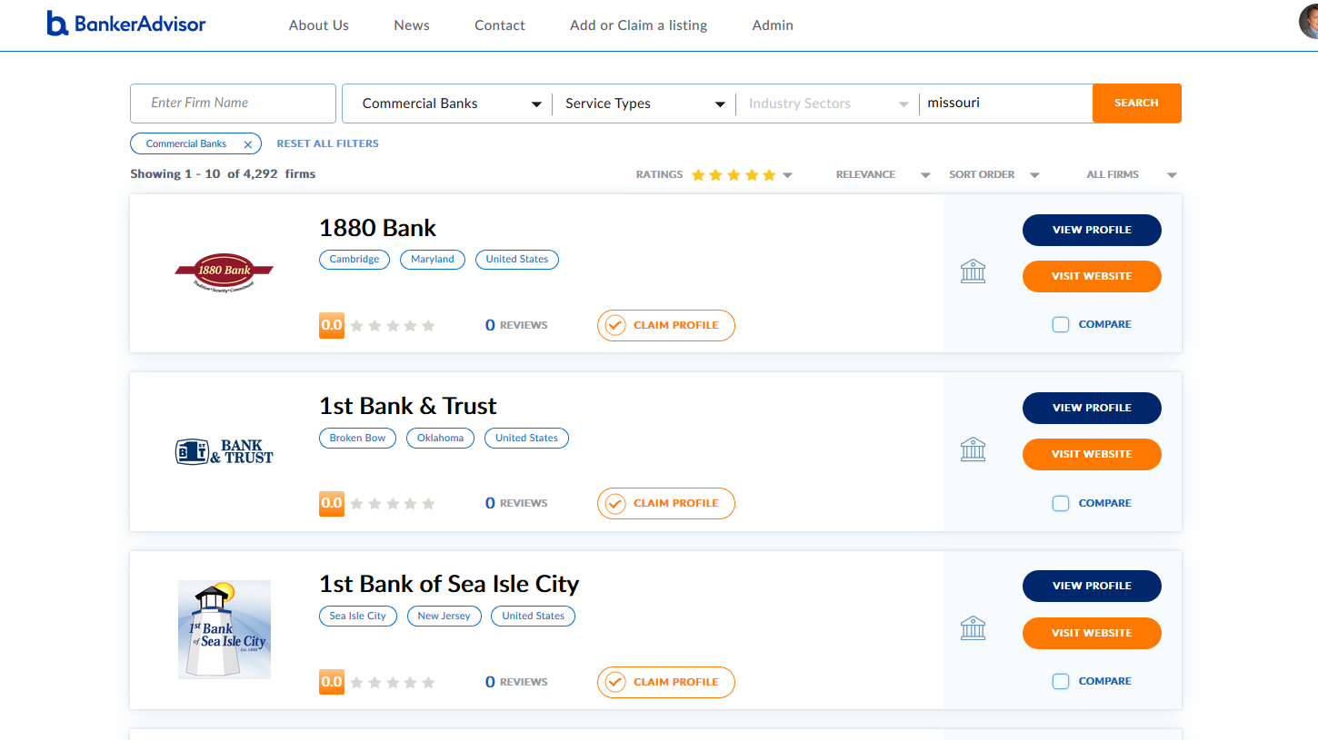

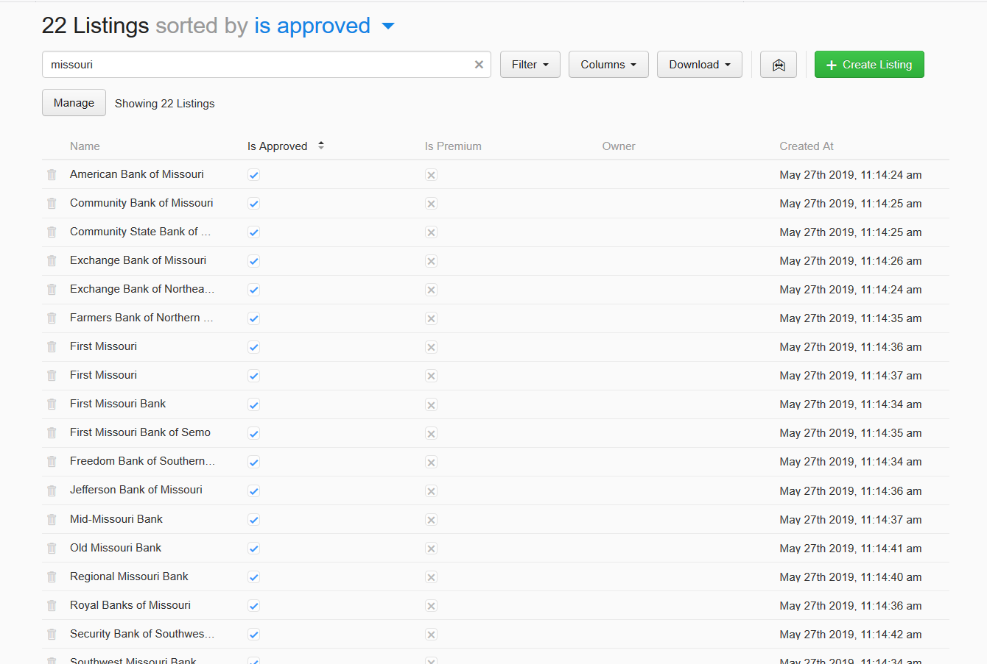

1. Find a firm button not working. The “Find a Firm” button this new page does not seem to be working properly.

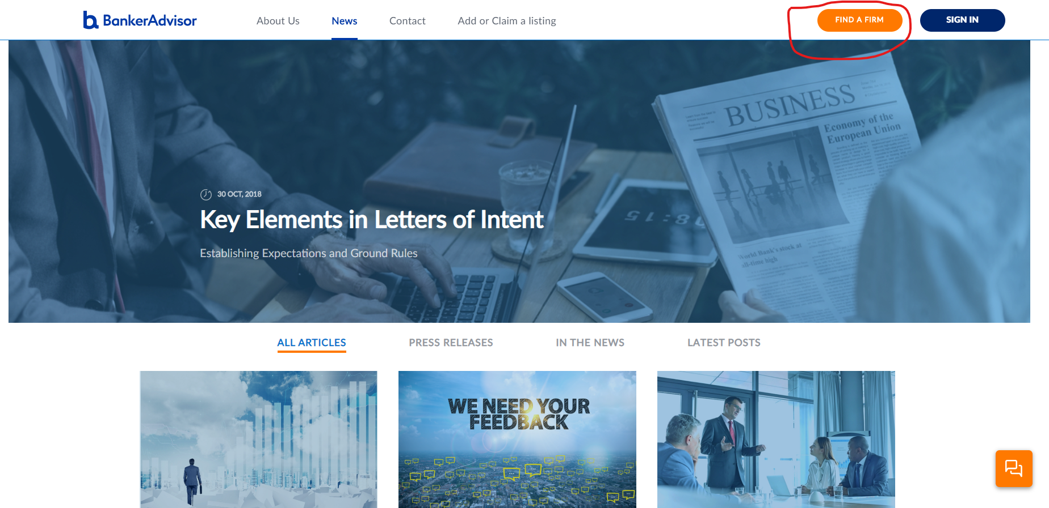

1. Industry Sectors – minor changes to description for healthcare. On the pull down, for the industry sector “healthcare”, I would like to change this to read “Healthcare and Life Sciences”

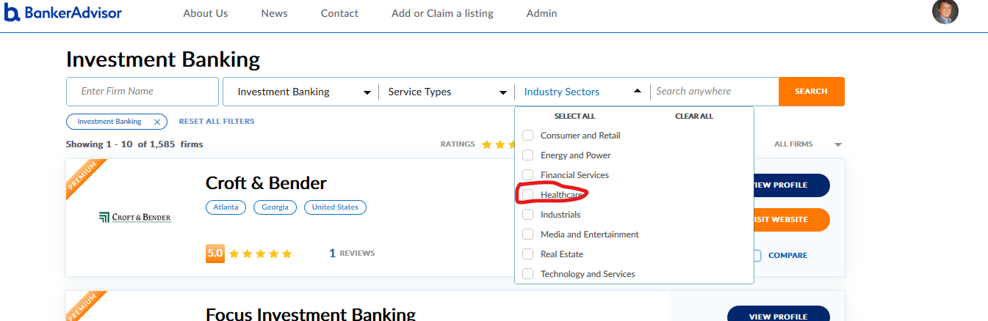

1. SEO fixes per SEO Audit – Fixing 19 pages with duplicate Meta Descriptions

<https://bankeradvisor.com/>

<https://bankeradvisor.com/about>

<https://bankeradvisor.com/advertise>

<https://bankeradvisor.com/advertise/get-reviews>

<https://bankeradvisor.com/advertise/programs>

<https://bankeradvisor.com/article/bankeradvisor-beta>

<https://bankeradvisor.com/article/before-the-banker-bake-off>

<https://bankeradvisor.com/article/key-elements-in-letters-of-intent>

<https://bankeradvisor.com/badges>

<https://bankeradvisor.com/community-guidelines>

<https://bankeradvisor.com/legal-notices>

<https://bankeradvisor.com/news>

<https://bankeradvisor.com/news/all-articles>

<https://bankeradvisor.com/news/in-the-news>

<https://bankeradvisor.com/news/latest-posts>

<https://bankeradvisor.com/news/press-releases>

<https://bankeradvisor.com/privacy>

<https://bankeradvisor.com/terms-of-service>

<https://bankeradvisor.com/terms-of-use>

1. Fixing 19 pages with duplicate <title> tags

<https://bankeradvisor.com/>

<https://bankeradvisor.com/about>

<https://bankeradvisor.com/advertise>

<https://bankeradvisor.com/advertise/get-reviews>

<https://bankeradvisor.com/advertise/programs>

<https://bankeradvisor.com/article/bankeradvisor-beta>

<https://bankeradvisor.com/article/before-the-banker-bake-off>

<https://bankeradvisor.com/article/key-elements-in-letters-of-intent>

<https://bankeradvisor.com/badges>

<https://bankeradvisor.com/community-guidelines>

<https://bankeradvisor.com/legal-notices>

<https://bankeradvisor.com/news>

<https://bankeradvisor.com/news/all-articles>

<https://bankeradvisor.com/news/in-the-news>

<https://bankeradvisor.com/news/latest-posts>

<https://bankeradvisor.com/news/press-releases>

<https://bankeradvisor.com/privacy>

<https://bankeradvisor.com/terms-of-service>

<https://bankeradvisor.com/terms-of-use>

1. Add “write a review” to the main tool bar on the home page and every page. I would like to add this here

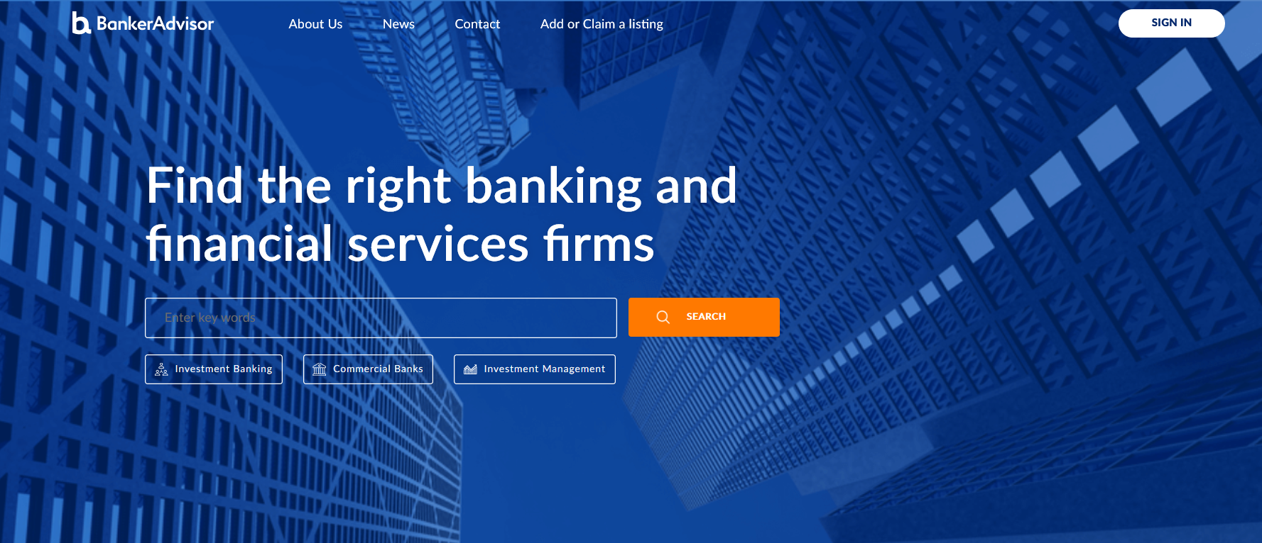

The way that the review firm functionality is set up, it accesses the review function after you are in a profile and assumes that the user will want to submit a review based on either Investment Banking, commercial banking or investment management based on the directory that the user is in at the time they select “Review Firm”. There are several firms that are featured (or will be when investment management is completed) in all 3. As a result, and because I would like to add a “Review a Firm” feature on the main tool bar, we will need to add a field to the review default page that permits the user to select the Service Type (ie Investment Banking, Commercial Banks, or Investment Management.

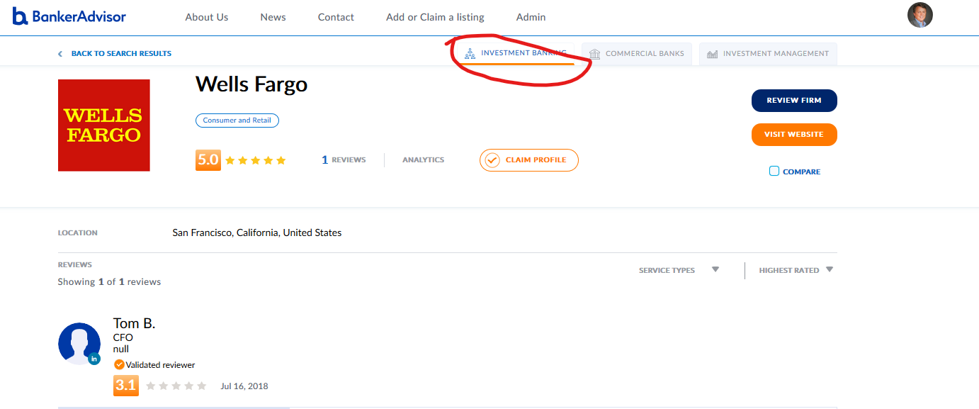

This is the webpage the user sees when select Review Firm from commercial banks and I would like to have a standard page that asks the user to select Service Category with a pull to select Investment Banking, Commercial Bank, or Investment Management. This selection would reconfigure the template to align with how we have it set up for each of these categories. This way the user can be reviewing the profile of Wells Fargo in investment banking and still launch a review on the Wells Fargo commercial bank services. This will also allow us to have a default page to send the user that selects “Review a Firm” on the main tool bar. It may makes sense for us to have brief call about this as I do not think this is a difficult change as all of the infrastructure is here we just need to add the Service Category pull down to the Review a Firm default screen as indicated here.

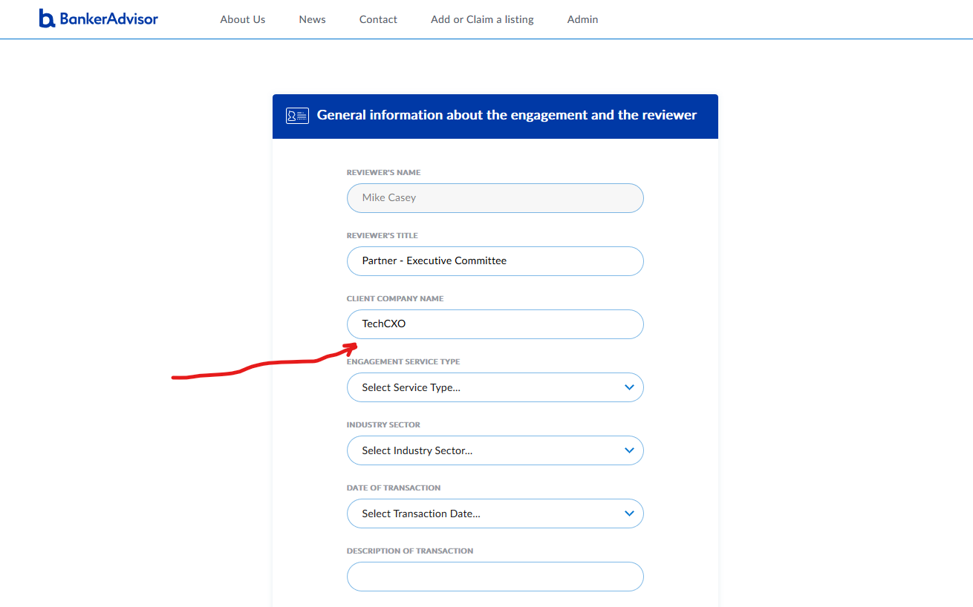

1. Alphabetical listing minor issues. We have several firms that appear out of alphabetical order if you do a search on all service categories. I am not sure why these appear at the end of the list but it would be helpful if we can figure this out and make adjustments so that they appear in alphabetical order in the results.

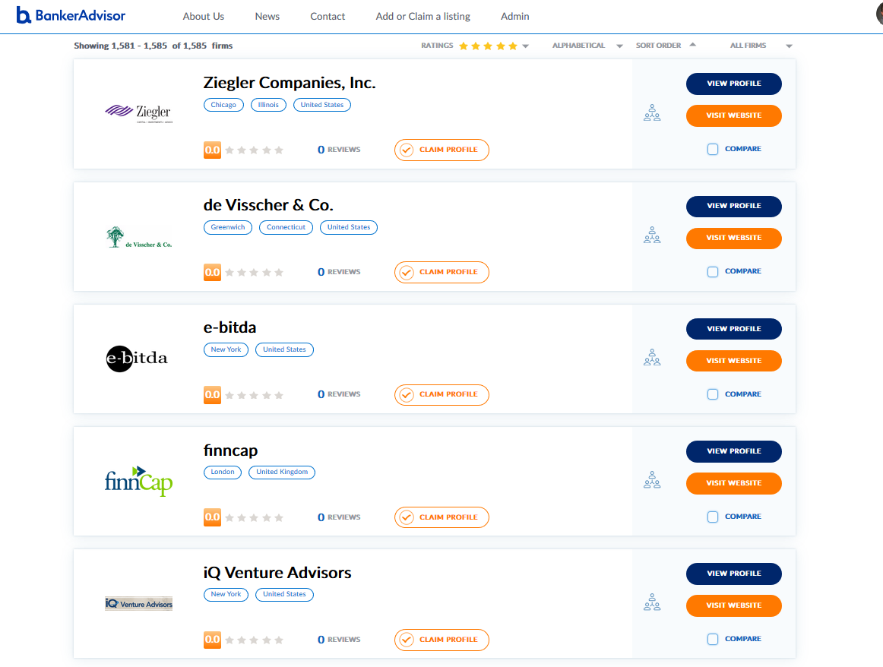

1. Listing Visits functionality. I would like to better understand how the “listing visits” counter works when you can. I think that this is important information but I am not sure how or when the count is being determined.

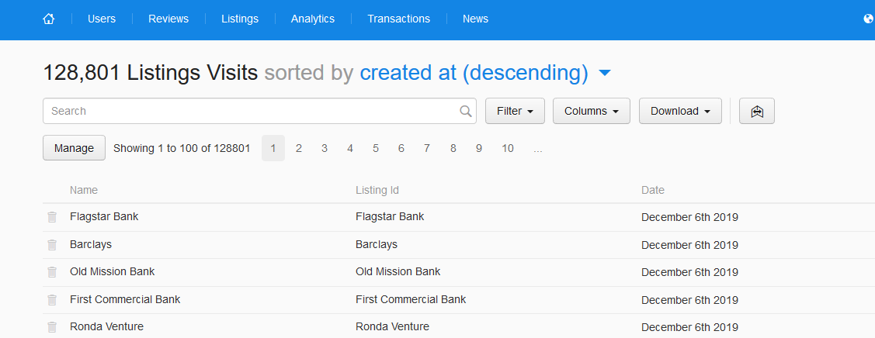

1. Admin Panel – General Window/template of Description. I would like to significantly increase the size of the window in the admin panel for the Description so that as we add descriptions to the listings this will be easier to perform. Also, some of the description may feature bullets or other punctuation and I am not sure if this is capable of handling these types of characters.

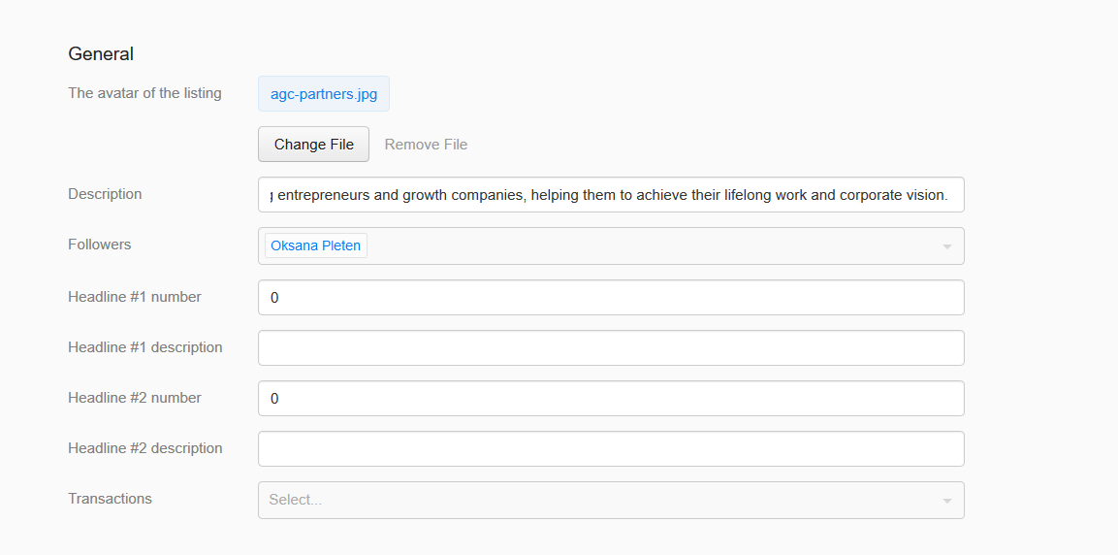

1. Admin Panel -Industries

Can we make this a pick list (check boxes) like the tool bar on the site? Adding industries requires typing and we have some great functionality on the site with a pull down with check boxes. I would like to feature this same type of functionality in the admin panel so that it is easy to designate the industries sectors like this.

